Recommendations on Meta Quest 3

Vasukumar Patel
Computer Engineering Technology - Computing Science
Algonquin College

6th March 2025

ENL2019T 309

Summary

The problem this report examines is the need for Meta Quest 3.
This study explores the setup of Meta Quest 3 as a solution.
The criteria the solution is tested against are battery life and charging, cost, and display & visual quality.
The recommendation is to use Meta Quest 3.

Table of Contents
Summary ii
List of Figures iv
List of Table v
1.0 Introduction 1
2.0 Problem Statement 2
2.1 Background – Problem: Need for Meta Quest 3 2
2.2 Theory – Solution: Setting up the Meta Quest 3. 2
3.0 Criteria 3
3.1 Battery Life and Charging 3
3.2 Cost 3
3.3 Display & Visual Quality 3
4.0 Results and Discussion (Criteria vs. Solution) 4
4.1 Fast Charging of Meta Quest 3 4
4.2 Cost of Meta Quest 3 4
4.3 Visual Quality of Meta Quest 3 5
5.0 Conclusion 6
6.0 Recommendation 7
References 8

List of Figures

Figure 1: Meta Quest 3 [1] 2
Figure 2: Meta Quest 3 with super-fast charging [2] 4
Figure 3: Meta Quest 3 with affordable cost [3] 5
Figure 4: Meta Quest 3 with high visual quality [4] 5

List of Table

Table 1: Meta Quest 3 Recommendation Criteria 6

Introduction

The purpose of the report is to make a recommendation on Meta Quest 3. The audience for This report is for technicians in the field of computer science. This report addresses the problem, and the problem is the need for a Meta Quest 3. The solution is to provide Meta Quest 3 with cameras and sensors. Chapter 2.0 of this report outlines the details of the problem and the proposed solution. Chapter 3.0 outlines the criteria list for evaluation. Chapter 4.0 of this report outlines the details of the Results and Discussion (Criteria vs. Solution). Chapter 5.0 outlines conclusion. Chapter 6.0 of this report outlines recommendation of the report, and the last page is the reference page.

2.0 Problem Statement

2.1 Background – Problem: Need for Meta Quest 3
An affordable Meta Quest 3 is needed with a camera and sensors to enhance the experience in gaming and education. The software must be fully compatible with all Meta Quest 3 devices to ensure seamless functionality. Additionally, the hardware must go through maintenance once a year, and it must support the software for smooth functionality.

2.2 Theory – Solution: Setting up the Meta Quest 3.
This report will explore Meta Quest 3 as the solution. The solution needs to be both cost-effective and long-lasting.

The Meta Quest 3 comes with two Touch Plus controllers. (see Figure 1).
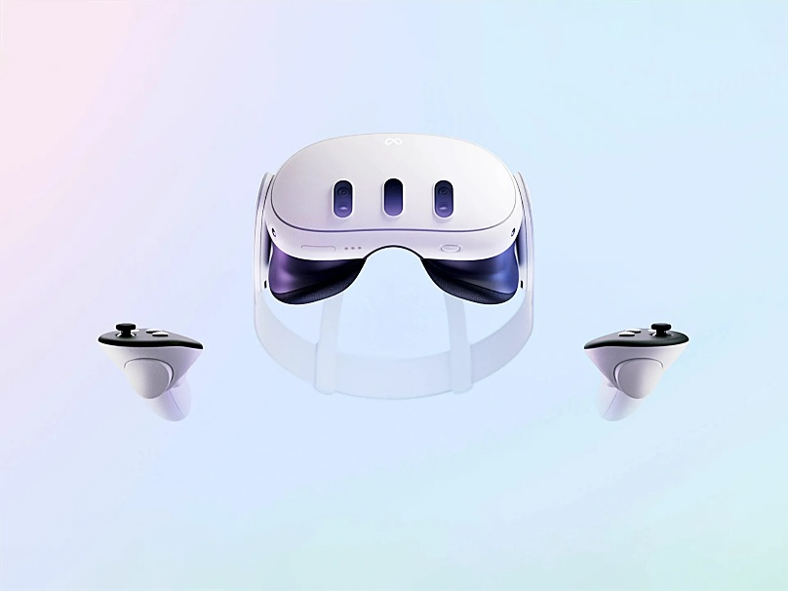
Figure 1: Meta Quest 3 [1]

3.0 Criteria

3.1 Battery Life and Charging
The Meta Quest 3 should be strong enough to last a long time and able to charge quickly for easy use.

3.2 Cost
The Meta Quest 3 should be made under $500.00 with one free-of-cost repair service.

3.3 Display & Visual Quality
The Meta Quest 3 should have a resolution of 2064 x 2208 pixels for a better visual experience. It should also use a mini-LED display to improve visual clarity, offering richer colour and enhanced contrast.

4.0 Results and Discussion (Criteria vs. Solution)

4.1 Fast Charging of Meta Quest 3
The goal is to ensure rapid charging, finishing in under 3 hours.
The battery information for the Meta Quest 3 is sourced from the Meta website, which offers precise technical specifications for hardware developed by Meta Corporation.
According to Meta, the Meta Quest 3 can be fully charged in about 2.3 hours [2].
This passes the criterion for fast charging.

The Meta Quest 3 comes with super fast charging. (see Figure 2).
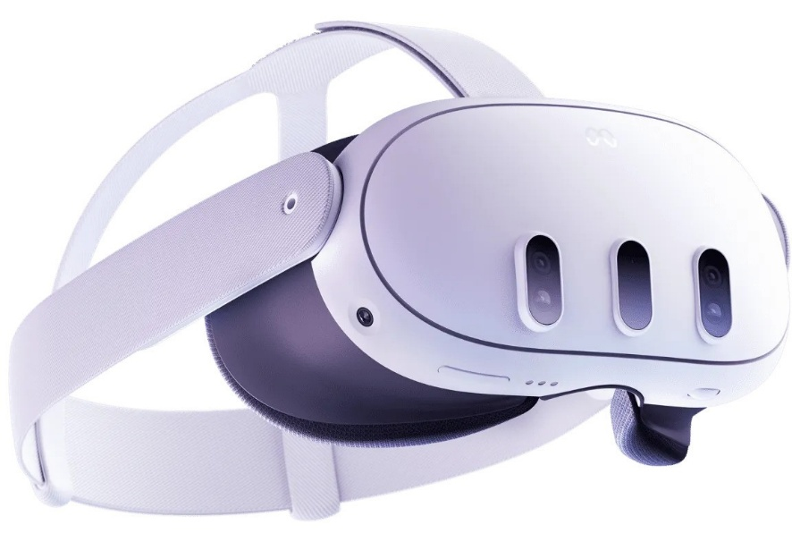
Figure 2: Meta Quest 3 with super-fast charging [2]

4.2 Cost of Meta Quest 3
The goal is to manufacture the Meta Quest 3 for under $500.00, including a complimentary repair service.
The manufacturing cost details for the Meta Quest 3 are taken from Android Central, which offers reliable information on the hardware costs developed by Meta Corporation.
Android Central reports that the manufacturing cost of the Meta Quest 3 is under $500.00 [3].
This passes the criterion for cost.

The Meta Quest 3 comes with affordable cost. (see Figure 3).
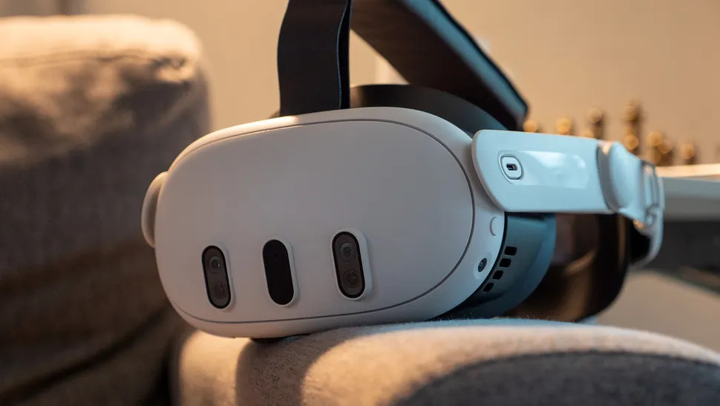
Figure 3: Meta Quest 3 with affordable cost [3]

4.3 Visual Quality of Meta Quest 3
The goal is to utilize a mini-LED display to enhance visual clarity, providing more vibrant colours and improved contrast.
The mini-LED information for the Meta Quest 3 is sourced from BGR, which provides dependable details about the mini-LED technology used by Meta Corporation in the Meta Quest 3.
BGR states that the Meta Quest 3 can utilize mini-LED technology to enhance visual quality [4].
This passes the criterion for visual quality.

The Meta Quest 3 comes with high visual quality. (see Figure 4).
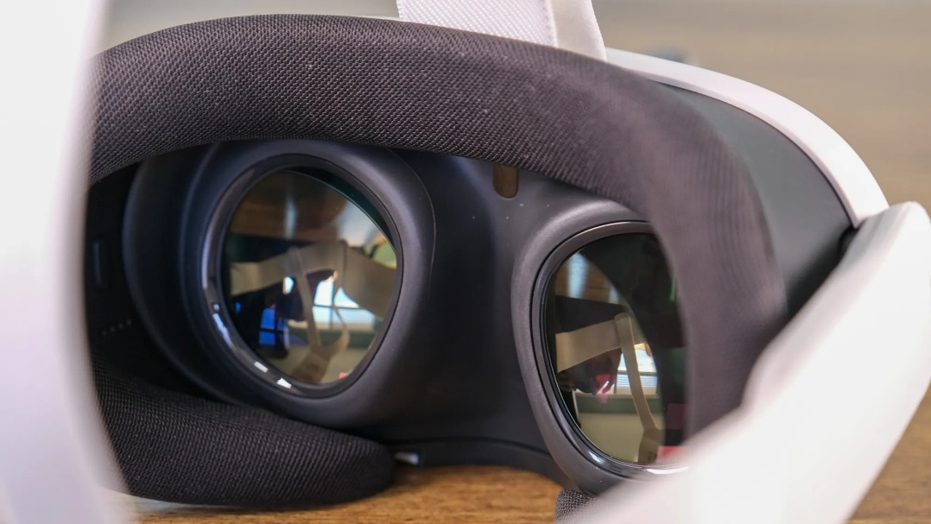
Figure 4: Meta Quest 3 with high visual quality [4]

5.0 Conclusion

Battery life and charging, cost, and display & visual quality are the main three criteria to evaluate Meta Quest 3. These criteria demonstrate that it meets all requirements. The device supports super-fast charging. It charges fully in 2.5 hours. In addition, it costs just $500.00, making it a budget-friendly option. The device has mini-LED technology, which ensures enhanced visual clarity, offering an improved user experience. Due to this, the Meta Quest 3 is a suitable and cost-effective solution for gaming and education. This report supports the adoption of Meta Quest 3 as a viable option for users seeking high performance at an affordable price.

All criteria for the Meta Quest 3 were passed (See Table 1).

Table 1: Meta Quest 3 Recommendation Criteria
Criteria | Pass | Fail
Battery life and charging | x
Cost | x
Display & Visual Quality | x

6.0 Recommendation

Due to the battery life and charging cost and display & visual quality provided, Meta Quest 3 is recommended.

References

[1] | B. Ashworth, “The Leaked Quest 3 Headset Video Teases Meta’s VR Ambitions,” wired.com, 23 August 2023. [Online]. Available: https://www.wired.com/story/meta-quest-3-headset-video-leak/. [Accessed 11 February 2025].
[2] | Meta, “Meta Quest 3,” Meta, [Online]. Available: https://www.meta.com/ca/quest/quest-3/. [Accessed 31 January 2025].
[3] | N. Sutrich, “This is how much the Meta Quest 3 really costs to make,” Android Central, 21 November 2023. [Online]. Available: https://www.androidcentral.com/gaming/virtual-reality/meta-quest-3-manufacturing-cost?utm_source=chatgpt.com. [Accessed 31 January 2025].
[4] | C. d. Looper, “Meta Quest 3 review: The best VR headset… for now,” BGR, 15 November 2023. [Online]. Available: https://bgr.com/reviews/meta-quest-3-review/. [Accessed 31 January 2025].

